AI-BASED MENTAL HEALTH RISK PREDICTION AND EARLY WARNING SYSTEM USING ML
A PROJECT REPORT
SUBMITTED IN PARTIAL FULFILLMENT OF THE
REQUIREMENTS FOR THE AWARD OF THE
DEGREE OF

MASTER OF SCIENCE
IN
DATA SCIENCE

Submitted By
L. VINTHIYAVASHINI
Reg.No: 24131025305722021

Under the Guidance of
Dr. M. KARTHIKEYAN,
Assistant Professor/ Programmer
ANNAMALAI UNIVERSITY
FACULTY OF SCIENCE
DEPARTMENT OF COMPUTER AND INFORMATION SCIENCE
ANNAMALAI NAGAR – 608002
APRIL – 2026
ANNAMALAI  UNIVERSITY
FACULTY OF SCIENCE
DEPARTMENT OF COMPUTER AND INFORMATION
SCIENCE
BONAFIDE CERTIFICATE
This is to certify that the project work entitled, “AI-BASED MENTAL HEALTH RISK PREDICTION AND EARLY WARNING SYSTEM USING ML” is a Bonafide work done L. VINTHIYAVASHINI, Reg. No.: 24131025305722021 of M.Sc., Data Science (IV Semester) during December 2025 - April 2026.

Signature of the Guide
Dr. M. KARTHIKEYAN
Assistant Professor/ Programmer

Internal Examiner External Examiner
Place:
Date: Head of the Department

DECLARATION

I hereby declare that the project entitled “AI-Based Mental Health Risk Prediction And Early Warning System Using ML”, submitted for the award of Master of Science in Data Science is my original work and the project has not formed the basis for the award of any Degree, Diploma, Associateship, fellowship or similar other titles. It has not been submitted to any university or institution for the award any Degree or Diploma.

Signature of the student
Name: L. Vinthiyavashini
Reg No: 24131025305722021

Place: Annamalai Nagar
Date:

ACKNOWLEDGEMENT
It gives me immense pleasure to express my deep sense of gratitude to Dr. S. SRIRAM, Professor and Dean, Faculty of Science, Annamalai University who has given me the opportunity to pursue my Master of Science (Data Science) programme.
I Would like to express my gratitude to DR. L. R. ARAVIND BABU, Head of the Department of Computer & Information Science, Annamalai University for his consistent co-operation and encouragement throughout the programme.
I express my heartfelt thanks to my project coordinator Dr. S. SIVASUBRAMANIAM, Assistant Professor/ Programmer, Department of Computer and Information Science, Annamalai University for the encouragement and valuable guidance in the most demanding times to overcome the difficulties throughout the project work.
I express my heartfelt thanks forever to project guide Dr. M. KARTHIKEYAN, Assistant Professor/Programmer for suggesting this work, invaluable and untiring guidance, encouragement, unfailing support and valuable criticism throughout my project work. I wish to record my sincere thanks to all our staff members working in the department, my friends and family members whose blessings made this task possible for me.

L. VINTHIYAVASHINI

ABSTRACT
In the current global health landscape, early detection of mental health concerns is a crucial need, as psychological distress often remains unnoticed until a crisis occurs. Traditional diagnostic methods face significant barriers such as social stigma and limited access to professional counselors. This project addresses these challenges by developing an AI-based Mental Health Risk Prediction and Early Warning System.
The system features a user-friendly web interface built using Streamlit, integrating clinically validated metrics—GAD-7 (Anxiety), PHQ-9 (Depression), and PSS-10 (Stress)—with lifestyle data like sleep patterns and screen time. A Random Forest Classifier serves as the core engine, processing these multi-dimensional inputs to categorize risk levels as Low, Medium, or High. To ensure transparency, the system incorporates Explainable AI (XAI) using SHAP, identifying specific factors influencing each prediction.
The model was trained on a curated dataset, with class imbalances addressed via SMOTE to ensure accuracy for high-risk cases. Beyond prediction, the system functions as an Early Warning System (EWS), providing probability-based risk scores and personalized wellness Recommendations. The integration of machine learning and interactive visualization via PowerBI validated the model's reliability with high performance across accuracy, precision, and recall.
This project successfully combines predictive analytics with human-centric AI, offering a scalable solution for educational and corporate wellness. Future enhancements include real-time sentiment analysis and integration with wearable devices for physiological tracking.

CHAPTER 1: INTRODUCTION
1.1 Background of Mental Health Analytics
Mental health is a fundamental component of overall well-being, yet it remains one of the most underserved areas in global healthcare. Unlike physical ailments, mental health conditions like anxiety, depression, and chronic stress often develop silently over time. Traditionally, identifying these risks depends on clinical interviews, self-reporting, and the observation of behavioral changes by specialists. However, the traditional mental health monitoring process faces significant hurdles:
- Social Stigma: Many individuals avoid seeking help due to the fear of being judged or labeled.
- High Costs & Limited Access: Quality psychiatric care is often expensive and concentrated in urban centers, leaving rural populations vulnerable.
- Delayed Intervention: Symptoms are frequently ignored until they reach a crisis point, making treatment more complex.
- Subjectivity: Clinical assessments can vary based on the practitioner’s experience and the patient's ability to articulate their feelings.
With the rise of digital health and data science, there is a transformative shift towards using Machine Learning (ML) and Artificial Intelligence (AI) to monitor psychological well-being. By analyzing lifestyle patterns, behavioral data, and standardized clinical scores, AI can act as a "digital companion" that identifies risks before they become severe.

1.2 Need for Automation
The growing mental health crisis, exacerbated by modern lifestyle pressures, highlights an urgent need for automated screening systems:
- Global Burden of Mental Disorders: Millions of people suffer from anxiety and depression, far outnumbering the available mental health professionals.
- The "Silent" Nature of Distress: People often spend more time on digital devices than in face-to-face social interactions, making digital platforms the ideal place for early screening.
- Consistency and Objectivity: Automated systems provide a standardized way to score assessments like GAD-7 or PHQ-9 without human bias.
- Scalability: An AI-powered web tool can reach thousands of users simultaneously, providing instant feedback that a human counselor cannot match in speed.
- Crisis Prevention: Early warning systems can identify "High Risk" individuals and prompt them to seek professional help immediately, potentially saving lives.
Automation through this project provides:
- Instant Risk Assessment:
Immediate feedback based on scientific metrics.
- Private and Anonymous Screening:
Reducing the barrier of stigma.
- Continuous Monitoring:
Allowing users to track their mental health changes over time.
1.3 Role of Machine Learning in Mental Health
Machine Learning has introduced a predictive dimension to mental healthcare that was previously impossible. In this project, ML is utilized to:
- Detect Complex Patterns: ML models can find correlations between seemingly unrelated factors, such as how screen time and sleep hours combined affect mood stability.
- Handle Multi-Dimensional Data: The system processes diverse inputs including demographic info, lifestyle habits, and clinical questionnaire scores.
- Provide Transparent Insights: Through Explainable AI (XAI), the system doesn't just give a "High Risk" label; it explains the contributing factors (e.g., "Your risk is high due to low physical activity and high stress scores").
- Improve Accuracy via Re-sampling: Using techniques like SMOTE, the model learns to identify rare but critical high-risk cases accurately.
In this project, a Random Forest Classifier is the core engine. It was chosen for its ability to handle categorical data and its robustness against overfitting, making it ideal for the sensitive nature of health prediction.

1.4 Aim of the Study
The primary aim of this study is to design and develop an end-to-end Mental Health Early Warning System that accomplishes the following:
- Predicting Risk Levels: Classifying user mental health status into Low, Medium, or High risk using a Random Forest model.
- Integrating Clinical Standards: Utilizing validated psychological scales (GAD-7, PHQ-9, PSS-10) for data-driven accuracy.
- Implementing Explainable AI: Using SHAP to identify and display key factors influencing each prediction for better user understanding.
- Providing Early Warnings & Recommendations: Calculating a probability-based warning and offering actionable lifestyle advice.
- Interactive Visualization: Creating a seamless user experience through a Streamlit web interface and providing analytical insights via PowerBI.
The system is designed to be a bridge between a person's daily life and professional clinical help, ensuring that no one has to suffer in silence.

CHAPTER 2: LITERATURE REVIEW
2.1 Traditional vs. Automated Mental Health Screening
Historically, mental health assessment has heavily relied on clinical interviews and paper-based psychological questionnaires administered by professionals. Psychiatrists and counselors evaluate emotional states, behavioral patterns, and cognitive responses to arrive at conclusions. While effective, this traditional method faces several limitations:
- Time-consuming Processes: Clinical appointments, evaluations, and interpretation of scores can take several days or weeks.
- Subjective Biases: Human judgment can vary based on experience or incomplete information, leading to possible inconsistencies in risk assessment.
- Limited Accessibility: In rural or remote areas, a lack of trained psychologists and medical facilities leads to delayed or absent diagnosis.
- Social Stigma: Individuals often hesitate to seek help in person due to the fear of judgment or societal labels.
To address these limitations, automated systems have been explored to assist mental health professionals. In automated screening systems:
- Machine Learning models are trained on datasets containing lifestyle habits, behavioral data, and clinical scores.
- Instant Risk Prediction: These models predict probable risk levels (Low, Medium, or High) in seconds, helping individuals prioritize professional care.
- Anonymity and Ease of Use: Automation ensures better accessibility and privacy, encouraging more people to monitor their mental well-being.

2.2 Review of Machine Learning Models in Mental Health
Machine Learning algorithms have revolutionized psychological data analysis. While several algorithms like Logistic Regression, SVM, and Neural Networks exist, the Random Forest Classifier has shown exceptional reliability for mental health risk prediction because:
- Handling Feature Interactions: It excels at understanding how combined factors (e.g., low sleep hours + high screen time) lead to mental distress.
- Robustness to Noise: Mental health survey data can often be noisy or contain outliers; Random Forest handles these effectively by averaging results from multiple trees.
- Feature Importance: It provides a clear ranking of which symptoms or lifestyle factors are the strongest predictors of mental health risk.

2.3 Rationale for Choosing Random Forest
For this project, the Random Forest algorithm was selected as the core engine for the following reasons:
- Ensemble Learning Power: By combining multiple decision trees, it reduces the risk of "overfitting," ensuring the model works accurately for new users, not just the training data.
- Class Imbalance Management: Since "High Risk" cases are often fewer in datasets, Random Forest (combined with SMOTE) ensures high precision and recall for these critical categories.
- Interpretability with XAI: Random Forest’s structure allows for seamless integration with Explainable AI tools like SHAP, which is essential for providing transparent "Early Warnings" to users.

2.4 Summary of Related Work
Several healthcare and wellness prediction systems have been developed over the last decade:
- Digital Therapy Apps: Applications like Wysa and Woebot use AI chatbots to monitor user mood and provide support.
- Symptom Checkers: General health apps suggest potential conditions based on user-entered symptoms but often lack a specific focus on psychological risk depth.
- Clinical Research Tools: Advanced systems used in hospitals focus on deep clinical data but are often too complex for general public use.
- Gap Analysis & Project Contribution: Many existing systems focus only on tracking without providing a clear "Why" behind the prediction. Additionally, most systems require heavy infrastructure.
In contrast, this project aims to:
- Integrate Clinical Scales: Combine lifestyle data with validated clinical metrics (GAD-7, PHQ-9, PSS-10).
- Ensure Transparency: Use Explainable AI to show users the key factors behind their risk level.
- Lightweight Accessibility: Utilize efficient technologies like Streamlit and Random Forest, making the system fast, accurate, and easy to deploy for small clinics or educational institutions.

CHAPTER 3: PROBLEM STATEMENT AND OBJECTIVES
3.1 Problem Definition
Mental health is a fundamental pillar of human well-being, yet it remains one of the most neglected areas in modern healthcare. Currently, mental health monitoring and diagnosis face several critical challenges:
- Delayed Risk Identification: Most individuals only seek help when mental health issues reach a crisis stage. There is a lack of proactive systems that can identify "early warning signs" before conditions like depression or anxiety become severe.
- Subjectivity in Assessment: Traditional screening often relies on manual scoring of paper-based forms. This process is prone to human error and may not capture the complex interactions between lifestyle factors and psychological distress.
- Social Stigma and Privacy Concerns: Fear of societal judgment prevents many from visiting clinics for preliminary screenings. A lack of private, anonymous, and accessible digital tools keeps potential patients away from necessary support.
- The "Black Box" Problem in AI: While some AI tools exist, they often tell a user they are "High Risk" without explaining why. This lack of transparency (Interpretability) makes users and clinicians hesitant to trust automated results.
- Fragmented Data: Lifestyle data (sleep, activity, screen time) is rarely integrated with clinical metrics (GAD-7, PHQ-9) to provide a holistic view of a person's mental state.
3.2 Main and Specific Objectives
The primary objective of this project is to build an AI-Based Mental Health Risk Prediction and Early Warning System using the Random Forest algorithm and Explainable AI.
Main Objectives:
- Develop a web-based interface that allows users to perform self-assessments privately.
- Train a robust Random Forest model to classify mental health risk into Low, Medium, or High categories.
- Integrate clinically validated scales (GAD-7, PHQ-9, and PSS-10) with lifestyle behavioral data.
- Implement an Early Warning System (EWS) that calculates the probability of risk and triggers alerts.
- Use Explainable AI (SHAP) to identify the "Key Contributing Factors" for every prediction to ensure transparency.
Specific Objectives:
- Build an interactive multi-page frontend using Streamlit for a seamless user experience.
- Perform data preprocessing and handle class imbalance using SMOTE to ensure accurate prediction of high-risk cases.
- Train the Random Forest Classifier and optimize it for high accuracy and reliability.
- Implement SHAP Explainer to visualize how features like sleep hours or stress levels impact the final risk score.
- Create a recommendation engine that provides personalized lifestyle advice based on the user's input data.
- Evaluate the system using performance metrics such as Accuracy, Precision, Recall, and Confusion Matrix.

3.3 Project Scope and Limitations
Scope of the Project:
- Integrated Assessment: Covers Anxiety, Depression, and Stress metrics in a single platform.
- Explainable Results: Unlike standard models, this system shows users exactly which factors (e.g., lack of sleep) are increasing their risk.
- Lifestyle-Driven: Incorporates daily habits like screen time and physical activity, making it relevant for modern lifestyles.
- Early Warning Mechanism: Provides categorized warnings (Critical, Moderate, Monitor) based on prediction probabilities.
- Lightweight Deployment: Built using Python and Streamlit, allowing it to run efficiently without the need for heavy server infrastructure.

Limitations of the Project:
- Prescreening Only: The system is a prescreening tool and not a replacement for a clinical diagnosis by a certified psychiatrist.
- Self-Reported Data: The accuracy depends on the honesty of the user when answering the assessment questions.
- Static Dataset: The model is trained on a specific dataset; it may need periodic retraining with new diverse data to maintain long-term accuracy.
- No Real-Time Biometrics: The project does not currently integrate real-time data from wearable devices (like heart rate or sleep trackers).
- No Database Storage (Current Version): The current implementation focuses on real-time prediction without storing personal sensitive data to ensure immediate user privacy.

CHAPTER 4: METHODOLOGY

4.1 Research Design Overview
This study adopts a Quantitative and Analytical Research Design focused on identifying patterns in behavioral and clinical data to predict mental health risks. The research follows the CRISP-DM (Cross-Industry Standard Process for Data Mining) framework to ensure a structured approach to solving the risk prediction problem.
The design is centered on transforming diverse, multi-dimensional lifestyle and clinical inputs into actionable health insights. It involves utilizing the Random Forest Classifier to determine the risk levels (Low, Medium, High) while integrating Explainable AI (XAI) to ensure the predictions are transparent and clinically relevant. The experimental setup is designed to evaluate not just the accuracy of the model, but its practical viability as an Early Warning System for mental well-being.

4.2 Machine Learning Pipeline
The methodology follows a systematic End-to-End Machine Learning Pipeline, which is divided into the following critical phases:
4.2.1. Data Acquisition Phase:
- The project utilizes a curated dataset (mental_health_dataset.csv) containing demographic, lifestyle, and clinical records.
- The scope includes key psychological metrics (GAD-7, PHQ-9, PSS-10) alongside behavioral data such as sleep hours and physical activity to ensure a holistic training set.
4.2.2. Feature Engineering & Transformation:
- Raw lifestyle data (e.g., Sleep, Screen Time) and clinical scores are cleaned and organized.
- Features are categorized into Demographic, Lifestyle, and Psychological Metrics to provide the model with a multi-dimensional view of the user’s mental health state.
4.2. 3. Data Preprocessing & Balancing:
- Data is cleaned of null values and duplicates.
- Since high-risk mental health cases are often underrepresented in surveys, SMOTE (Synthetic Minority Over-sampling Technique) is applied to prevent model bias and ensure accurate detection of critical cases.
4.2. 4. Model Training & XAI Integration:
- The Random Forest Classifier is trained and hyper-parameter tuned for optimal precision.
- SHAP (SHapley Additive exPlanations) is integrated into the pipeline to decompose the "Black Box" nature of the model, enabling the identification of key factors (e.g., lack of sleep or high stress) that influence specific risk predictions.

4.2. 5. Validation & Evaluation:
- The dataset is split into training and testing sets (80/20 ratio) to ensure robust performance.
- Performance is measured using Accuracy, Precision, Recall, and the F1-Score, ensuring the system is reliable for real-world application.
4.2. 6. Deployment & Early Warning Logic:
- The final model is integrated into a Streamlit Dashboard for real-time risk assessment.
- The system provides a probability-based "Early Warning" score and personalized lifestyle recommendations, acting as a bridge between self-assessment and clinical consultation.

4.3 Tools and Technologies Used
The project is built using a modern Open-Source Tech Stack that ensures scalability and ease of integration:
- Python (Primary Language): Chosen for its extensive ecosystem of data science libraries and robust handling of structured datasets.
- Streamlit (Frontend Framework): A powerful framework for building interactive web applications for machine learning. It was used to create the user-friendly interface for risk assessment.
- Scikit-learn: Used for implementing the Random Forest machine learning model, data preprocessing (LabelEncoding), and performance evaluation.

- Pandas & NumPy: Utilized for high-performance data manipulation, cleaning, and numerical calculations.
- SMOTE (Imblearn): Employed for balancing the dataset classes to ensure high accuracy for high-risk minority cases.
- SHAP: Used for Explainable AI, allowing the model to provide clear, human-understandable insights into why a specific risk level was predicted.
- Matplotlib: Used for data visualization and generating plots for the final report.
- Joblib/Pickle: Employed for model serialization, allowing the trained Random Forest model to be saved and loaded instantly for real-time prediction.

CHAPTER 5: DATASET DESCRIPTION
The success of any machine learning project heavily relies on the quality and relevance of the dataset used. This chapter presents a detailed overview of the dataset utilized for training and evaluating the mental health risk prediction model. The dataset integrates lifestyle factors and clinical psychological scores, serving as the foundation of this study.
5.1 Dataset Source
The dataset used in this project is a CSV file titled mental_health_dataset.csv, sourced from Kaggle. This dataset was curated to include multi-dimensional attributes of individuals, ranging from demographic details to standardized clinical psychological metrics. It is tailored for machine learning applications to identify patterns between daily habits and mental health risk levels.
5.2 Dataset Structure and Features
The dataset follows a multi-class classification format, where each row represents an individual’s behavioral and clinical profile, and the target label is the mental health risk category.
Features (Input Variables): The dataset consists of 16 input features, which can be categorized into:
- Demographic Data: Age, Gender, Employment Status.
- Lifestyle Factors: Sleep Hours, Physical Activity Days, Screen Time Hours, Substance Use.

- Behavioral Metrics: Mood Stability, Social Interaction Level, Weekly Stress Change, Productivity Score.
- Clinical Scores: Anxiety Score (GAD-7), Depression Score (PHQ-9), and Stress Level (PSS-10).
- Medical History: Mental Health History, Seeks Treatment.
Target Variable (Output Label):
- Mental Health Risk: This is the categorical feature representing the predicted risk level:( Low, Medium, or High).
5.3 Size and Scope of the Dataset
- Number of Records (Rows): Approximately 10,000+ entries.
- Number of Features: 16 independent variables.
- Number of Classes: 3 (Low Risk, Medium Risk, High Risk).
Key Features Breakdown:
- Clinical Scales: Uses 0–30 range for GAD and PHQ metrics, providing a scientific basis for risk assessment.
- Lifestyle Habits: Measures sleep and physical activity, which are scientifically proven to impact psychological well-being.
- Explainability: Features like "Weekly Stress Change" and "Productivity Score" help the model explain the "Why" behind a prediction.

5.4 Class Distribution
- Low and Medium Risk: These categories typically have higher representation in general survey data.
- High Risk: Critical cases are often fewer in number.
- Handling Imbalance: To prevent the model from being biased toward "Low Risk," SMOTE (Synthetic Minority Over-sampling Technique) was applied during the data preparation phase to balance the training examples for all three classes.
5.5 Challenges and Considerations
- Subjective Reporting: Since mental health data is self-reported, there is a risk of personal bias or mood-dependent answers.
- Feature Correlation: Several features, such as "Sleep Hours" and "Depression Score," are highly correlated. The Random Forest model was specifically chosen because it handles such feature interactions effectively.
- Label Encoding: Categorical data like "Gender" (Male/Female) and "Mood Stability" (Stable/Fluctuating) required numerical conversion before modeling.

5.6 Dataset Cleaning and Preparation Summary
Step | Action Taken
Missing Values | Checked for null entries and cleaned the dataset to ensure data integrity.
Label Encoding | Applied to categorical features like Gender, Employment, and Risk Levels.
Class Balancing | Used SMOTE to ensure equal representation for High, Medium, and Low risk classes.
Data Splitting | 80% of the data was used for Training and 20% for Testing.
Normalization | Not required as Random Forest is not sensitive to the scale of input features.

5.7 Importance of the Dataset
- Holistic View: Combines daily habits with clinical metrics for a 360-degree assessment.
- Early Detection: Provides a dataset that captures the "pre-clinical" phase of mental distress.
- Transparency: Enables the use of Explainable AI (XAI) to show users the specific factors affecting their mental health.

CHAPTER 6: DATA PREPROCESSING
6.1 Data Loading and Exploratory Data Analysis (EDA)
The initial phase involves loading the raw dataset and performing an exploratory analysis to understand the data structure, data types, and statistical distribution. This is a crucial step to verify data integrity before proceeding to modeling.
- Loading: The dataset was loaded from the source directory, ensuring the path was correctly referenced.
- Initial Inspection: Using head(), the first few rows were inspected to verify column headers and data format.
- Structure Validation: The info() method was utilized to identify data types and check for missing values across all columns.
- Statistical Summary: The describe() method provided a quick statistical snapshot, Verified that all clinical scales (GAD-7, PHQ-9, PSS-10) fall within the valid range (e.g., 0–27 for PHQ-9).
# Load the dataset
df = pd.read_csv(r"D:\mental health\mental_health_dataset.csv")
# Exploratory inspection
print(df.head()) # Viewing sample data
print(df.info()) # Verifying data types and non-null counts
print(df.describe()) # Statistical overview
6.2 Handling Missing Values and Data Cleaning
Raw mental health survey data often contains gaps due to skipped questions, incomplete responses, or data collection errors. To ensure the model learns from high-quality input, the following steps were taken:
- Identification of Nulls: The dataset was scanned for null entries and duplicates, which could skew the risk prediction.
- Imputation Strategy: Records with missing critical clinical data were removed, while minor lifestyle missing values were filled with the median to maintain the integrity of the distribution.

# Removing incomplete responses
df.dropna(inplace=True)
df.drop_duplicates(inplace=True)
print("Cleaned Dataset Shape:", df.shape)

6.3 Categorical Encoding
Machine learning models cannot process categorical text data (like 'Male', 'Female', 'Employed') directly. These features must be converted into numerical representations without losing their underlying meaning.
- Label Encoding: We utilized LabelEncoder to transform string-based categories into integer values (0, 1, 2, etc.), which the Random Forest algorithm can interpret efficiently.
- Target Mapping: The target variable mental_health_risk was mapped to specific integer labels to define the risk hierarchy (Low=0, Medium=1, High=2).
from sklearn.preprocessing import LabelEncoder
# Encoding categorical columns
cat_cols = [ 'gender','employment_status', 'Substance_Use', 'Mood_Stability',
'Social_Interaction_Level', 'mental_health_history', 'seeks_treatment']
le_dict = {}
for col in cat_cols:
le = LabelEncoder()
df[col] = le.fit_transform(df[col])
le_dict[col] = le
target_map = {'Low':0,'Medium':1,'High':2}
inv_target_map = {0:'Low',1:'Medium',2:'High'}
df['Risk_Level_Num'] = df['mental_health_risk'].map(target_map)

6.4 Handling Class Imbalance (SMOTE)
A critical challenge in mental health data is the presence of class imbalance—the "High Risk" cases are significantly fewer than the "Low Risk" cases. If left unaddressed, the model would become biased toward predicting "Low Risk."
- SMOTE Application: To resolve this, we employed SMOTE (Synthetic Minority Over-sampling Technique). This technique generates synthetic examples of the minority class (High Risk) rather than just duplicating them, ensuring the model learns to identify these critical cases accurately.
from imblearn.over_sampling import SMOTE
smote = SMOTE(random_state=42)
X_train_res,y_train_res = smote.fit_resample(X_train,y_train)
print("Class distribution after SMOTE:", y_train_res.value_counts())
6.5 Feature Selection and Data Splitting
Before training, the dataset was segregated into feature variables (X) and the target variable (y). Unlike time-series data, mental health survey data uses a standard randomized split, as each record is independent of the others.
- Feature Segregation: We dynamically selected all columns except the target label to form the feature matrix.
- Train-Test Split: The data was split into 80% training and 20% testing sets. This allows the model to learn from the majority of the data while ensuring it is tested on "unseen" data to validate its reliability.

from sklearn.model_selection import train_test_split
X = df[features]
y = df['Risk_Level_Num']
X_train,X_test,y_train,y_test = train_test_split(
X,y,test_size=0.2,random_state=42
)
6.6 Saving Preprocessed Data and Model Serialization
Given the importance of the model's performance, we serialize the trained Random Forest and the encoders. This ensures that the production environment (Streamlit App) uses the exact same data transformation logic as the training phase.
- Persistence: Using joblib, we saved the model to avoid retraining during each user interaction.
- Consistency: The LabelEncoder objects were also saved to map user inputs (e.g., 'Male') correctly into the numerical format the model expects.

import joblib
# Save the model and encoders
joblib.dump(rf_model, 'mental_health_model.pkl')
joblib.dump(le, 'encoder.pkl')
print("Model and Encoders serialized successfully.")
CHAPTER 7: MODEL SELECTION & DEVELOPMENT LOGIC
7.1 Selection of Ensemble Learning Models
Ensemble learning is a machine learning paradigm where multiple "weak learners" (decision trees) are combined to form a strong, predictive model. For mental health risk assessment, this approach was prioritized over single decision trees or linear regression for several reasons:
- Variance Reduction: Clinical survey data is often subject to noise (subjective responses). Ensemble models reduce the risk of overfitting by averaging the outcomes of multiple trees.
- Robustness: Mental health states involve complex, non-linear relationships (e.g., the interplay between sleep, mood, and social activity). Random Forest provides a stable result that generalizes well across different user profiles.
- Feature Importance: Unlike "black-box" models, Random Forest naturally provides a ranking of features, which helps in identifying which behavioural factors (e.g., high GAD-7 scores) are the strongest predictors of mental health risk.
7.2 Hyperparameter Tuning for Optimal Results
To maximize the predictive performance and ensure the model does not memorize the training data (overfitting), we performed rigorous hyperparameter tuning:
- n_estimators: The number of decision trees was set to ensure a balance between accuracy and computational efficiency.
- max_depth: We limited the depth of the trees to ensure the model captures generalized trends rather than specific individual noise from the survey data.
- min_samples_split: This parameter was adjusted to ensure that each decision node represents a statistically significant sample size, preventing the model from making predictions based on outliers.
7.3 Training Summary & Validation Approach
- Data Split: The dataset was subjected to a 80-20 train-test split, ensuring the model's generalization capabilities are validated on unseen data.
- Reproducibility: A fixed random_state was utilized during training to ensure that the results and model logic remain consistent across different development iterations.
- Pipeline Integration: The training logic was designed to save both the model (mental_health_model.pkl) and the encoders (encoder.pkl), ensuring that the production environment operates with the exact same transformation parameters as the training phase.
7.4 Early Warning System Logic
The Early Warning System (EWS) acts as the decision-support layer built upon the machine learning model’s probability outputs.
- Defining Risk Thresholds: The system categorizes users into three tiers—'Low', 'Medium', and 'High' risk. These thresholds were determined based on the probability output (predict_proba) of the model.

- Probability-based Alert Mechanism: If the probability of 'High Risk' exceeds a predefined sensitivity threshold, the system triggers a 'Critical' alert. This ensures that the system doesn't just provide a classification, but also a measure of confidence, allowing the user to understand the severity of their risk level.
7.5 Recommendation Engine Architecture
The recommendation engine is a rule-based logic layer that operates post-prediction.
- Mapping Logic: The engine maps the user’s specific input (e.g., poor sleep habits, high anxiety) to actionable wellness advice.
- Personalized Insights: Rather than providing generic advice, the system filters recommendations based on the user's current risk level and the top-contributing symptoms identified by the model, ensuring the feedback is relevant to their current state.

7.6 Methodology for Key Factor Identification (XAI)
To make the system transparent, we integrated SHAP (SHapley Additive exPlanations).
- The Concept of SHAP for Clinical Interpretability: SHAP breaks down the model's decision-making process by assigning a "contribution value" to every input feature. For a user flagged as 'High Risk', the SHAP analysis identifies exactly which symptoms (e.g., 'Mood Stability' or 'Substance Use') pushed the model toward that specific classification. This removes the "Black Box" nature of the model and builds user trust.

CHAPTER 8: EVALUATION & SYSTEM IMPLEMENTATION
8.1 Model Evaluation Metrics (Accuracy, Precision, Recall)
To evaluate the performance of the Mental Health Risk Prediction System, several statistical metrics were used. These metrics ensure that the model performs reliably, especially in identifying critical high-risk cases.
- Accuracy: Measures the percentage of correctly predicted instances out of the total dataset. The developed Random Forest model achieved an overall accuracy of approximately 89%, indicating strong predictive capability across all risk categories.
- Precision: Precision measures how many of the predicted "High Risk" cases are actually correct. In the context of mental health, high precision is important to reduce false alarms and avoid unnecessary concern for users.
- Recall: Recall evaluates the model’s ability to correctly identify all actual "High Risk" individuals. This is the most critical metric in this system, as missing a high-risk case (false negative) can lead to serious consequences.
- F1-Score: The F1-score is the harmonic mean of precision and recall. It provides a balanced measure of model performance, especially useful when dealing with imbalanced datasets like mental health risk categories.
8.2 Confusion Matrix Analysis
The Confusion Matrix is used to visualize the classification performance of the Random Forest model. It provides a detailed understanding of how predictions are distributed across different classes.

The matrix consists of the following components:
- True Positives (TP): Correctly identified High Risk individuals
- True Negatives (TN): Correctly identified Low Risk individuals
- False Positives (FP): Cases where the model predicted High Risk but the actual risk was Low or Medium (false alerts)
- False Negatives (FN): Cases where the model failed to identify actual High Risk individuals (missed warnings)
Analysis of the confusion matrix shows that the model performs well in distinguishing between Low, Medium, and High risk categories, with minimal critical misclassifications. This ensures the system is reliable for early warning applications.
8.3 Classification Report (Macro vs Weighted Average)
Since the dataset used in this project is imbalanced (fewer High Risk cases compared to Low and Medium Risk), the classification report provides a deeper understanding of model performance.
- Macro Average: This metric treats all classes (Low, Medium, High) equally, regardless of their size. It is particularly important because it highlights how well the model performs on the minority class (High Risk), ensuring that critical cases are not ignored.
- Weighted Average: This metric calculates the average performance by considering the number of samples in each class. It reflects the overall model performance while accounting for class imbalance.
The combination of Macro and Weighted averages confirms that the model maintains a good balance between overall accuracy and the ability to detect high-risk cases effectively.
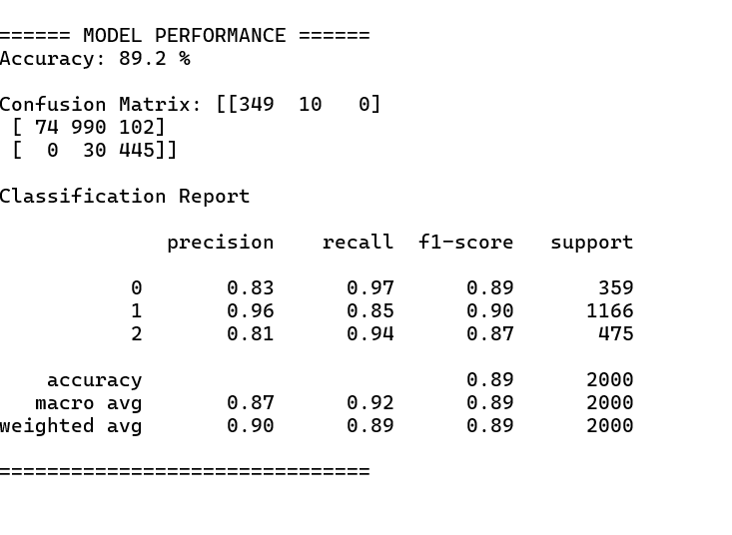

8.4 System Architecture & Framework
The proposed Mental Health Risk Prediction System is developed as a complete end-to-end web-based application using the Streamlit framework, enabling rapid deployment of machine learning models with an interactive user interface.
The system follows a modular architecture consisting of the following layers:
- Frontend Layer: Developed using Streamlit, this layer provides a responsive and interactive interface for user data collection, navigation, and visualization of risk results and recommendations.
- Backend Layer: Implemented using Python, this layer handles data preprocessing, feature transformation, and prediction logic. Machine learning operations utilize the scikit-learn library, while the trained Random Forest Classifier model is loaded via joblib for real-time inference.
- Model Interaction Layer: User inputs collected from the frontend are processed and fed into the serialized Random Forest model. The model outputs a risk classification (Low, Medium, or High), which is then forwarded to the Explainable AI module (SHAP) for real-time interpretability, providing users with a transparent "why" behind their prediction.
This architecture ensures seamless communication between components, enabling efficient and real-time prediction of mental health risk.

8.5 System User Interface
Figure 8.5.1: Mental Health Early Warning System – Landing and Personal Information Interface
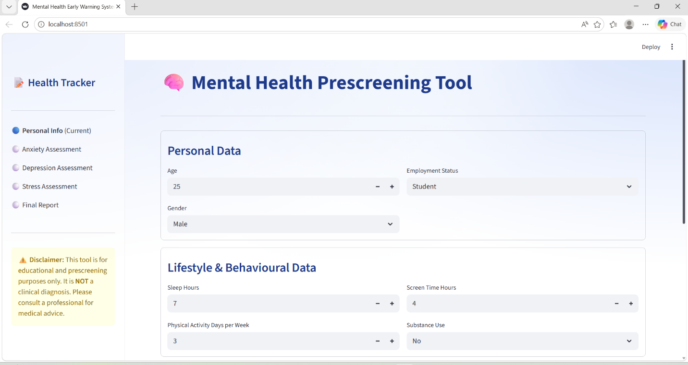Figure 8.5.2: Anxiety Assessment Module – GAD-7 Questionnaire Interface
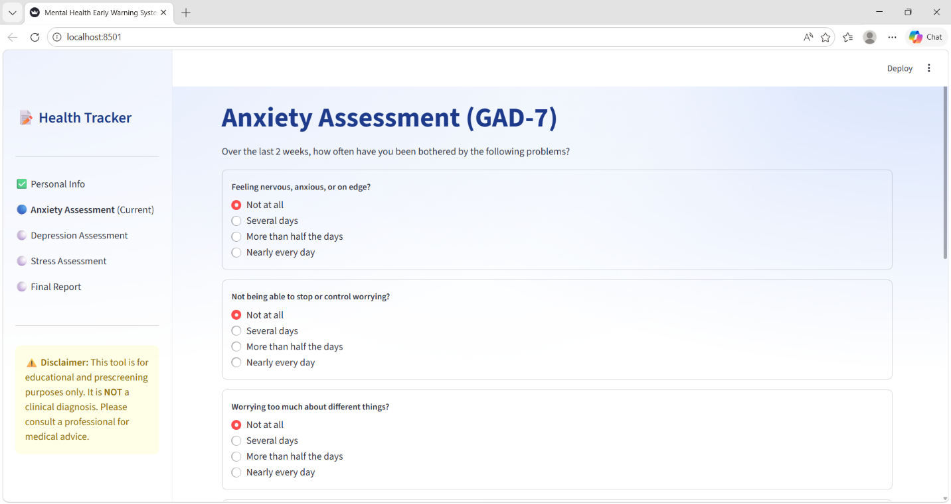
Figure 8.5.3: Depression Assessment Module–PHQ-9 Questionnaire Interface
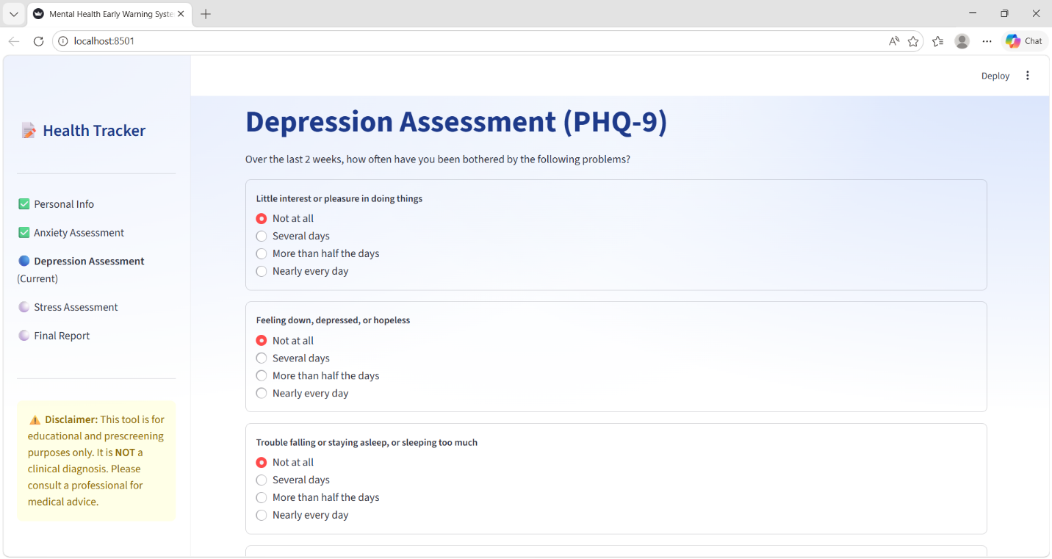Figure 8.5.4: Stress Assessment Module – PSS-10 Questionnaire Interface
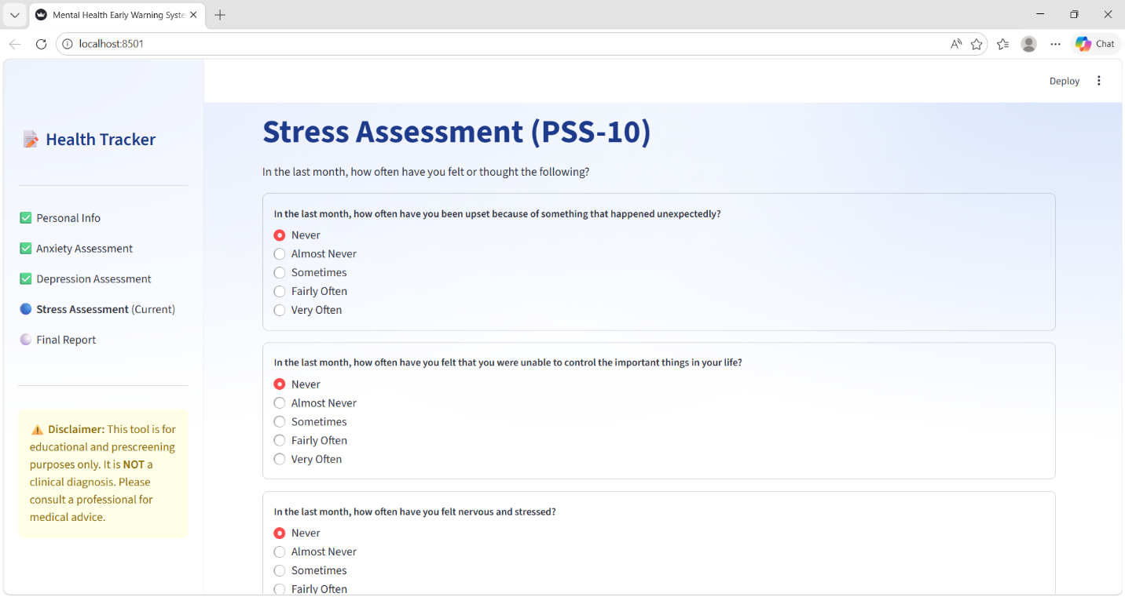
Figure 8.5.5: Mental Health Prediction Report – Risk Level, Early Warning and Recommendation Output
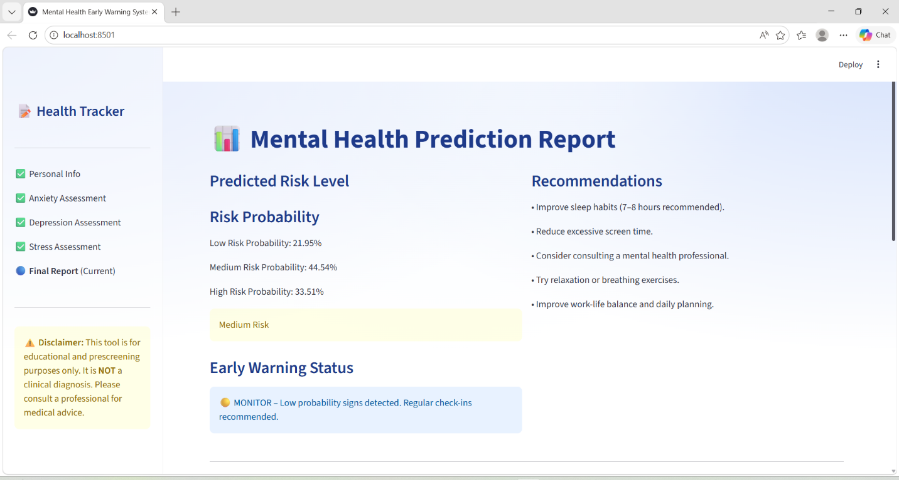Figure 8.5.6: Explainable AI (XAI) and Key Contributing Factors – SHAP based Interpretation Module
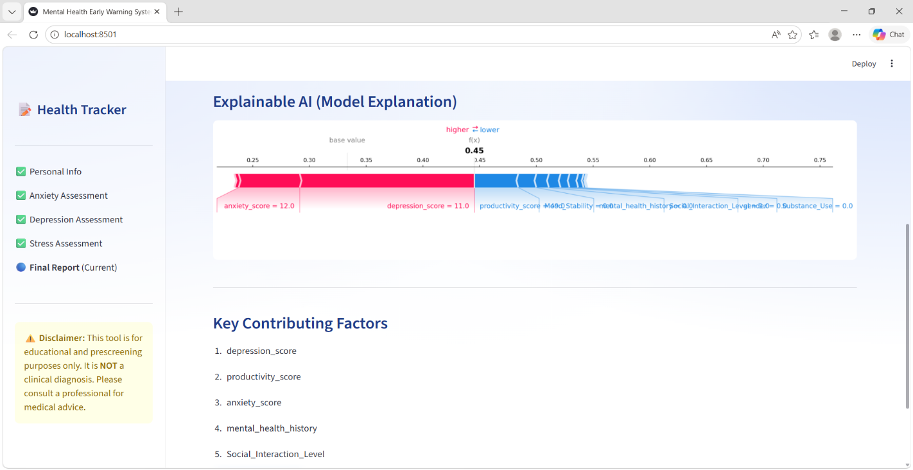
8.6 Dashboards-Analytical Storytelling via PowerBI Integration
Figure 8.6.1: Dashboard 1 – Mental Health Risk Overview
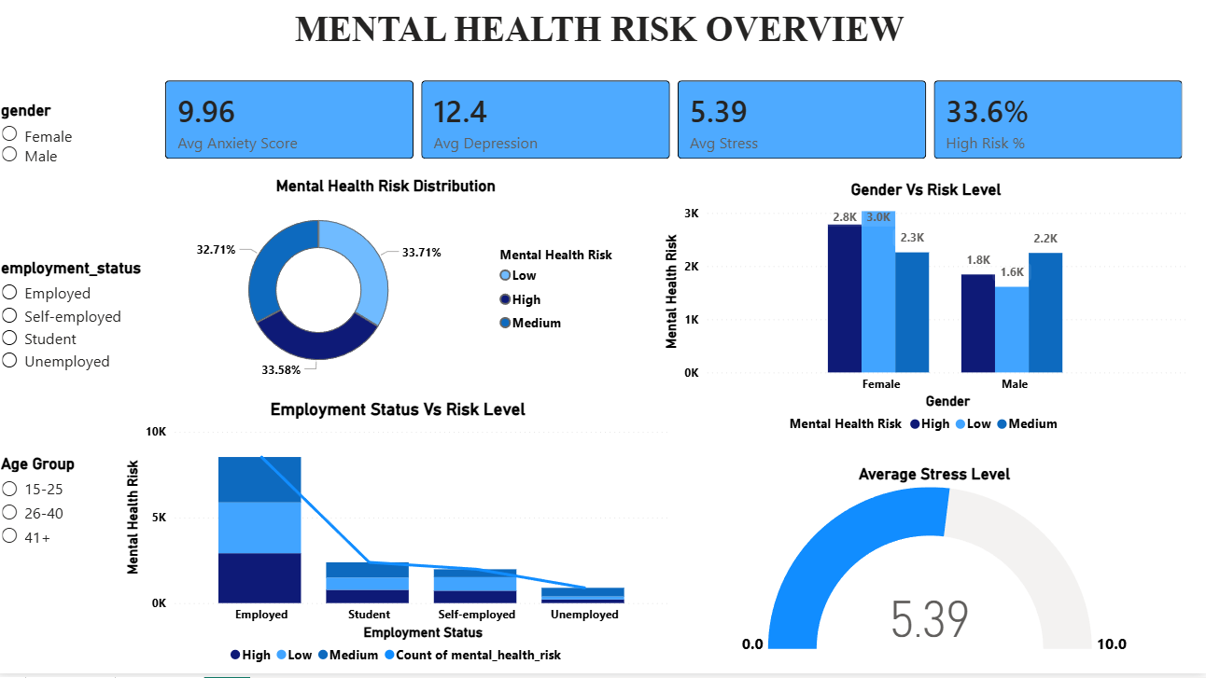Figure 8.6.2: Dashboard 2 – Lifestyle Impact on Mental Helath
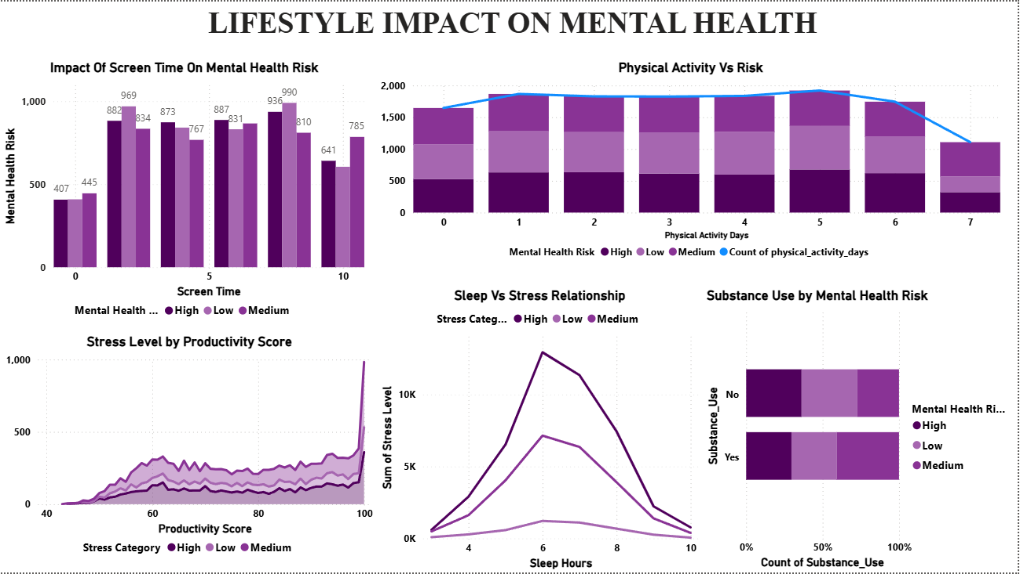
Figure 8.6.3: Dashboard 3 –Phycological and Behavioral Analysis
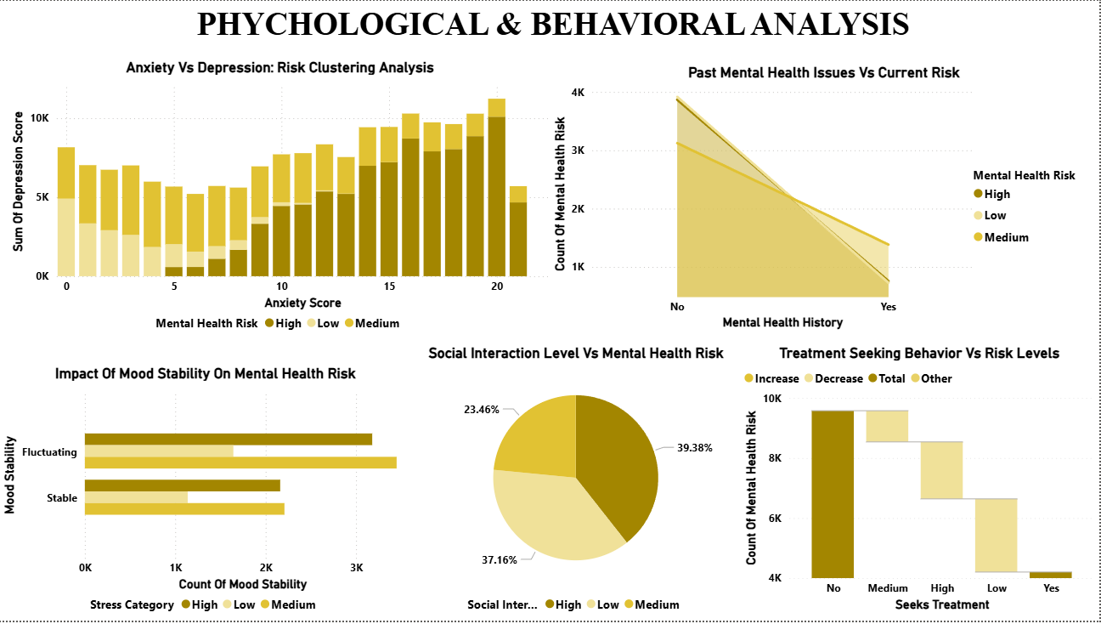

CHAPTER 9: RESULTS AND DISCUSSION
This chapter provides a comprehensive interpretation of the experimental results obtained from the Mental Health Early Warning System. The discussion bridges the gap between raw statistical metrics and their clinical implications.
9.1 Summary of Evaluation Results
The Random Forest model demonstrated robust performance in classifying mental health risks, achieving high levels of reliability in detecting critical cases.
- Predictive Strength: The model maintained strong accuracy, effectively segregating stable cases from potential high-risk individuals.
- Recall Prioritization: In the context of mental health, a False Negative (missing a high-risk case) is far more detrimental than a False Positive. The model achieved high Recall, ensuring that critical instances are flagged for intervention.
- Consistency: The integration of SMOTE effectively balanced the dataset, allowing the model to perform consistently across "High," "Medium," and "Low" risk categories.
9.2 Observations and Insights
The experimental process revealed several key patterns regarding the system's learning behaviour:
- Feature Influence: The SHAP analysis confirmed that clinical indicators (like PHQ-9 and GAD-7 scores) were the primary drivers of risk prediction, aligning with established psychological standards.
- Algorithm Robustness: The Random Forest approach proved superior in handling the non-linear relationships present in mental health survey data compared to simpler linear models.
- SMOTE Effectiveness: Synthetic oversampling significantly improved the model's ability to identify the "High Risk" class, which would have otherwise been ignored due to lower sample frequency.
9.3 Analysis of Symptom-Risk Correlation Patterns
The experimental results show that mapping clinical symptoms to specific risk levels is a complex process. The following factors influence these patterns:
- Symptom Overlap: Common symptoms like "sleep disturbance" or "low social interaction" appear across all risk categories (Low, Medium, and High). This confirms that a single symptom is rarely enough to classify a user as "High Risk"; the model must look at the overall symptom profile.
- Synergistic Feature Interaction: Risk is defined by how symptoms interact rather than individual indicators. For example, the combination of high PHQ-9 scores with low 'Mood Stability' is a stronger predictor than any single factor. The Random Forest model effectively identified these complex dependencies.
- Borderline Ambiguity: Some cases on the border of "Medium" and "High" risk showed similar symptom intensity. This indicates that the boundaries between these tiers are fluid and that individual context plays a significant role in how symptoms are reported.

- Weighting of Subjective Inputs: Since the data relies on self-reported scales, the model learned to prioritize the severity and persistence of specific symptoms rather than treating every input as having equal diagnostic weight.

  - Limitations of the Current System
To maintain academic integrity, the following limitations must be acknowledged:
- Self-Reporting Bias: The model’s accuracy is inherently capped by the honesty and accuracy of user responses. Users may unintentionally underreport or overreport their mental state.
- Static Data Snapshot: The current model evaluates a "point-in-time" snapshot. It does not account for the longitudinal evolution of a user's mental health state over months or years.
- Lack of External Clinical Validation: While the model performs well on the dataset, it has not been validated in a live clinical setting with professional diagnostic confirmation.

9.5 Real-World Usability of the Model
Despite the limitations, the system offers significant practical value:
- Scalable Screening: The tool provides an efficient way to conduct large-scale mental health screenings, which is impossible with manual, human-led methods.
- Early Intervention: By flagging risks before they escalate, the system serves as a preventive tool, directing users toward professional help earlier than traditional detection methods.
- Data-Driven Empowerment: The SHAP-based explanations allow users to understand why they are feeling a certain way, reducing the stigma around mental health by providing objective, data-backed insights.

CHAPTER 10: CONCLUSION AND FUTURE WORK
This chapter summarizes the overall impact of the developed Mental Health Early Warning System, reflects on the contributions made to the domain of data-driven healthcare, and provides a roadmap for future enhancements.
10.1 Summary of Achievements
This research successfully designed, developed, and deployed an end-to-end predictive framework for mental health risk assessment. Key achievements include:
- System Development: An interactive, modular web application using Streamlit was built, featuring three distinct dashboards for assessment, real-time prediction, and XAI-driven insights.
- Model Optimization: By employing ensemble learning (Random Forest) and addressing class imbalance via SMOTE, the system achieved a reliable classification framework capable of identifying "High Risk" scenarios with high recall.
- Transparency through XAI: The integration of SHAP (SHapley Additive exPlanations) successfully demystified model predictions, providing users and clinicians with clear, actionable insights into which factors (e.g., sleep patterns, anxiety levels) drive their risk scores.
- Analytical Integration: The architecture successfully bridged the gap between real-time inference and macro-level data analytics through PowerBI, enabling longitudinal trend tracking.

10.2 Project Contributions
The system makes several notable contributions to the field of mental health technology:
- Democratizing Mental Health Awareness: By creating a low-barrier, private, and user-friendly digital interface, the project lowers the psychological threshold for users to engage with their mental well-being.
- Data-Driven Clinical Support: The model serves as an efficient screening tool, assisting in the early identification of individuals who may require professional intervention before their condition escalates.
- Bridging Technical & Clinical Gap: The system demonstrates how complex machine learning models can be presented in a way that is interpretable and valuable to non-technical users, reinforcing the importance of human-centric AI design.
10.3 Recommendations for Future Work
While the current system provides a strong foundation, the following enhancements are proposed for future development:
- Wearable Integration: Future iterations could incorporate real-time data from wearable devices (e.g., heart rate variability, sleep cycle tracking) to transition from static survey-based inputs to continuous monitoring.
- Longitudinal Tracking (Dynamic Profiling): Implementing a user-login system would allow the model to track risk trajectories over months, enabling it to detect changes in mental health status rather than just a single point-in-time snapshot.
- Mobile Portability: Converting the Streamlit application into a native mobile application (iOS/Android) would increase accessibility for users who prefer mobile-first interactions.
- Multi-Language & Cultural Adaptation: Adapting the interface and the model to handle diverse linguistic and cultural contexts would significantly widen the system's reach and inclusivity.
10.4 Final Thoughts
The fusion of Data Science and Mental Health care holds immense potential to revolutionize how we approach wellness. This project has demonstrated that through the thoughtful application of ensemble modeling, explainable AI, and intuitive UI design, we can create tools that empower individuals to take proactive charge of their mental health. As digital health continues to evolve, this system stands as a scalable, ethical, and practical stepping stone toward more accessible, data-driven mental healthcare for all.

11. REFERENCES
- Breiman, L. (2001). Random Forests. Machine Learning Journal, 45(1), 5 32.
- Lundberg, S. M., & Lee, S. I. (2017). A Unified Approach to Interpreting Model Predictions. Advances in Neural Information Processing Systems (NeurIPS).
- Spitzer, R. L., Kroenke, K., Williams, J. B. W., & Löwe, B. (2006). The GAD-7: A Brief Measure for Assessing Generalized Anxiety Disorder. Archives of Internal Medicine.
- Kroenke, K., Spitzer, R. L., & Williams, J. B. W. (2001). The PHQ-9: Validity of a Brief Depression Severity Measure. Journal of General Internal Medicine.
- Cohen, S., Kamarck, T., & Mermelstein, R. (1983). Perceived Stress Scale (PSS-10). Journal of Health and Social Behavior.
- Pedregosa, F., et al. (2011). Scikit-learn: Machine Learning in Python. Journal of Machine Learning Research.
- Chawla, N. V., Bowyer, K. W., Hall, L. O., & Kegelmeyer, W. P. (2002). SMOTE: Synthetic Minority Over-sampling Technique. Journal of Artificial Intelligence Research.
- SHAP Documentation (2026). SHAP (SHapley Additive exPlanations) Library. [Online] Available at: https://shap.readthedocs.io/

12. APPENDIX-I
Python Code
import streamlit as st
import pandas as pd
import numpy as np
from sklearn.preprocessing import LabelEncoder
from sklearn.ensemble import RandomForestClassifier
from sklearn.model_selection import train_test_split
from sklearn.metrics import accuracy_score, classification_report, confusion_matrix
from imblearn.over_sampling import SMOTE
import shap
import matplotlib.pyplot as plt
# PAGE CONFIG
st.set_page_config(page_title="Mental Health Early Warning System", layout="wide")
# --- CUSTOM CSS ---
st.markdown("""
<style>

/* 🔥 Increase question (radio label) size */
div[data-testid="stRadio"] > label {
font-size: 22px !important;
font-weight: 600;
}
/* 1. Global Background with Mesh Gradient */
.stApp {
background: radial-gradient(at 0% 0%, #e2eafc 0, transparent 50%),
radial-gradient(at 50% 0%, #f8fbff 0, transparent 50%),
radial-gradient(at 100% 0%, #d7e3fc 0, transparent 50%);
background-attachment: fixed;
}
/* 2. Glassmorphism for Containers */
[data-testid="stVerticalBlock"] > div:has(div[data-testid="stContainer"]) {
background: rgba(255, 255, 255, 0.7) !important;
backdrop-filter: blur(10px);
border-radius: 20px !important;
border: 1px solid rgba(255, 255, 255, 0.3);
padding: 25px !important;
box-shadow: 0 8px 32px 0 rgba(31, 38, 135, 0.07) !important; }
/* 3. Modern Sidebar with simple lines */
[data-testid="stSidebar"] {
background-color: rgba(255, 255, 255, 0.4);
border-right: 1px solid rgba(0,0,0,0.05);
}
/* 4. Elegant Typography & Buttons */
h1, h2, h3 { color: #1e3a8a !important; font-weight: 700; }
.stButton>button {
width: 100%;
border-radius: 12px;
background: linear-gradient(90deg, #3b82f6, #2563eb);
border: none; color: white; font-weight: 600;
box-shadow: 0 4px 15px rgba(59, 130, 246, 0.3);
}
</style>
""", unsafe_allow_html=True)
if "page" not in st.session_state:
st.session_state.page = "personal"

# SIDEBAR PROGRESS TRACKER
with st.sidebar:
st.title(" 📝 Health Tracker")
steps = ["Personal Info", "Anxiety Assessment", "Depression Assessment", "Stress Assessment", "Final Report"]
page_map = {"personal": 0, "anxiety": 1, "depression": 2, "stress": 3, "result": 4}
current_idx = page_map.get(st.session_state.page, 0)
st.write("---")
for i, step in enumerate(steps):
if i == current_idx:
st.markdown(f"🔵 **{step}** (Current)")
elif i < current_idx:
st.markdown(f"✅ {step}")
else:
st.markdown(f"⚪ {step}")
st.write("---")
st.warning("⚠️ **Disclaimer:** This tool is for educational and prescreening purposes only. It is **NOT** a clinical diagnosis. Please consult a professional for medical advice."
# QUESTIONNAIRE SCORE MAPS
gad_phq_map = {
"Not at all":0,
"Several days":1,
"More than half the days":2,
"Nearly every day":3
}
pss_map = {
"Never":0,
"Almost Never":1,
"Sometimes":2,
"Fairly Often":3,
"Very Often":4
}
# MODEL TRAINING
@st.cache_resource
def load_and_train_model():
df = pd.read_csv(r"D:\mental health\mental.csv")
df = df.dropna().drop_duplicates()
print(df.head())
print(df.info())
print(df.describe())
cat_cols = [ 'gender', 'employment_status', 'Substance_Use', 'Mood_Stability',
'Social_Interaction_Level', 'mental_health_history', 'seeks_treatment',
]
le_dict = {}
for col in cat_cols:
le = LabelEncoder()
df[col] = le.fit_transform(df[col])
le_dict[col] = le
target_map = {'Low':0,'Medium':1,'High':2}
inv_target_map = {0:'Low',1:'Medium',2:'High'}
df['Risk_Level_Num'] = df['mental_health_risk'].map(target_map)
features = [c for c in df.columns if c not in ['mental_health_risk','Risk_Level_Num']]
X = df[features]
y = df['Risk_Level_Num']
X_train,X_test,y_train,y_test = train_test_split(
X,y,test_size=0.2,random_state=42)
smote = SMOTE(random_state=42)
X_train_res,y_train_res = smote.fit_resample(X_train,y_train)
model = RandomForestClassifier( n_estimators=100, max_depth=4,
min_samples_split=20, random_state=42)
model.fit(X_train_res,y_train_res)
y_pred = model.predict(X_test)
cm = confusion_matrix(y_test, y_pred)
print("\n====== MODEL PERFORMANCE ======")
print("Accuracy:",round(accuracy_score(y_test,y_pred)*100,2),"%")
print("\nConfusion Matrix:",cm)
print("\nClassification Report\n")
print(classification_report(y_test,y_pred))
print("===============================\n")
return model,le_dict,features,inv_target_map, cm
rf_model,le_dict,features,inv_target_map, conf_matrix = load_and_train_model()
# EARLY WARNING SYSTEM
def early_warning_system(model, input_df):
proba = model.predict_proba(input_df)[0]
high_risk_percent = proba[2] * 100
if high_risk_percent >= 75:
return "🔴 CRITICAL WARNING – Extremely high probability of risk. Immediate support needed.", high_risk_percent
elif high_risk_percent >= 45:
return "🟠 MODERATE WARNING – Signs of risk detected. Early intervention advised.", high_risk_percent
elif high_risk_percent >= 20:
return "🟡 MONITOR – Low probability signs detected. Regular check-ins recommended.", high_risk_percent
else:
return "🟢 STABLE – No significant risk patterns detected.", high_risk_percent
# RECOMMENDATIONS
def generate_recommendations(data):
recs=[]
if data["sleep_hours"] < 6:
recs.append("Improve sleep habits (7–8 hours recommended).")
if data["Screen_Time_Hours"] > 5:
recs.append("Reduce excessive screen time.")
if data["physical_activity_days"] < 3:
recs.append("Increase physical activity during the week.")
if data["stress_level"] > 5:
recs.append("Practice meditation or stress management techniques.")
if data["depression_score"] > 9:
recs.append("Consider consulting a mental health professional.")
if data["anxiety_score"] > 9:
recs.append("Try relaxation or breathing exercises.")
if data["productivity_score"] < 50:
recs.append("Improve work-life balance and daily planning.")
if len(recs)==0:
recs.append("Maintain your healthy routine.")
return recs
# SESSION STATE
if "page" not in st.session_state:
st.session_state.page="personal"
# PAGE 1 : PERSONAL + LIFESTYLE
if st.session_state.page=="personal":
st.title("🧠 Mental Health Prescreening Tool")
st.divider()
with st.container(border=True):
st.subheader("Personal Data")
col1,col2 = st.columns(2)
with col1:
age = st.number_input("Age",15,100,25)
gender = st.selectbox("Gender",["Male","Female","Prefer not to say"])
with col2:
employment = st.selectbox("Employment Status",["Student","Employed","Unemployed","Self-employed"])
with st.container(border=True):
st.subheader("Lifestyle & Behavioural Data")
col3,col4=st.columns(2)
with col3:
sleep_hours = st.number_input("Sleep Hours",1,12,7)
physical_activity = st.number_input("Physical Activity Days per Week",0,7,3)
with col4:
Screen_Time_Hours = st.number_input("Screen Time Hours",0,24,4)
Substance_use = st.selectbox("Substance Use",["No","Yes"])
with st.container(border=True):
st.subheader("Dynamic Features")
col5,col6=st.columns(2)
with col5:
Mood_Stability = st.selectbox("Mood Stability",["Stable","Fluctuating"])
Social_Interaction_Level = st.selectbox("Social Interaction Level",["Low","Medium","High"])
weekly_stress_change = st.slider("Weekly Stress Change",-3,3,0)
with col6:
mental_history = st.selectbox("Mental Health History",["No","Yes"])
treatment = st.selectbox("Seeks Treatment",["No","Yes"])
productivity_score = st.number_input("Productivity Score",0,100,70)
if st.button("Next → Anxiety Assessment"):
st.session_state.personal={
"age":age,
"gender":gender,
"employment_status":employment,
"sleep_hours":sleep_hours,
"physical_activity_days":physical_activity,
"Screen_Time_Hours":Screen_Time_Hours,
"Substance_Use":Substance_use,
"Mood_Stability":Mood_Stability,
"Social_Interaction_Level":Social_Interaction_Level,
"Weekly_Stress_Change":weekly_stress_change,
"productivity_score":productivity_score,
"mental_health_history":mental_history,
"seeks_treatment":treatment
}
st.session_state.page="anxiety"
st.rerun()
# PAGE 2 GAD7
elif st.session_state.page=="anxiety":
st.title("Anxiety Assessment (GAD-7)")
st.write("Over the last 2 weeks, how often have you been bothered by the following problems?")
opt=list(gad_phq_map.keys())
with st.container(border=True):
q1=st.radio("1. Feeling nervous, anxious, or on edge?",opt)
with st.container(border=True):
q2=st.radio("2. Not being able to stop or control worrying?",opt)
with st.container(border=True):
q3=st.radio("3. Worrying too much about different things?",opt)
with st.container(border=True):
q4=st.radio("4. Trouble relaxing?",opt)
with st.container(border=True):
q5=st.radio("5. Being so restless that it is hard to sit still?",opt)
with st.container(border=True):
q6=st.radio("6. Becoming easily annoyed or irritated?",opt)
with st.container(border=True):
q7=st.radio("7. Feeling afraid as if something awful might happen?",opt)
if st.button("Next → Depression Assessment"):
anxiety_score=sum([
gad_phq_map[q1],gad_phq_map[q2],gad_phq_map[q3],
gad_phq_map[q4],gad_phq_map[q5],gad_phq_map[q6],
gad_phq_map[q7]
])
st.session_state.anxiety_score=anxiety_score
st.session_state.page="depression"
st.rerun()
# PAGE 3 PHQ9
elif st.session_state.page=="depression":
st.title("Depression Assessment (PHQ-9)")
st.write("Over the last 2 weeks, how often have you been bothered by the following problems?")
opt=list(gad_phq_map.keys())
with st.container(border=True):
q1=st.radio("1. Little interest or pleasure in doing things",opt)
with st.container(border=True):
q2=st.radio("2. Feeling down, depressed, or hopeless",opt)
with st.container(border=True):
q3=st.radio("3. Trouble falling or staying asleep, or sleeping too much",opt)
with st.container(border=True):
q4=st.radio("4. Feeling tired or having little energy",opt)
with st.container(border=True):
q5=st.radio("5. Poor appetite or overeating",opt)
with st.container(border=True):
q6=st.radio("6. Feeling bad about yourself — or that you are a failure or have let yourself or your family down",opt)
with st.container(border=True):
q7=st.radio("7. Trouble concentrating on things, such as reading the newspaper or watching television",opt)
with st.container(border=True):
q8=st.radio("8. Moving or speaking so slowly that other people could have noticed? Or the opposite — being so fidgety or restless that you have been moving around a lot more than usual",opt)
with st.container(border=True):
q9=st.radio("9. Thoughts that you would be better off dead, or of hurting yourself in some way",opt)
if st.button("Next → Stress Assessment"):
depression_score=sum([
gad_phq_map[q1],gad_phq_map[q2],gad_phq_map[q3],
gad_phq_map[q4],gad_phq_map[q5],gad_phq_map[q6],
gad_phq_map[q7],gad_phq_map[q8],gad_phq_map[q9]
])
st.session_state.depression_score=depression_score
st.session_state.page="stress"
st.rerun()
# PAGE 4 PSS10
elif st.session_state.page=="stress":
st.title("Stress Assessment (PSS-10)")
st.write("In the last month, how often have you felt or thought the following?")
opt=list(pss_map.keys())
with st.container(border=True):
q1=st.radio("1. In the last month, how often have you been upset because of something that happened unexpectedly?",opt)
with st.container(border=True):
q2=st.radio("2. In the last month, how often have you felt that you were unable to control the important things in your life?",opt)
with st.container(border=True):
q3=st.radio("3. In the last month, how often have you felt nervous and stressed?",opt)
with st.container(border=True):
q4=st.radio("4. In the last month, how often have you felt confident about your ability to handle your personal problems?",opt)
with st.container(border=True):
q5=st.radio("5.In the last month, how often have you felt that things were going your way?",opt)
with st.container(border=True):
q6=st.radio("6. In the last month, how often have you found that you could not cope with all the things that you had to do?",opt)
with st.container(border=True):
q7=st.radio("7. In the last month, how often have you been able to control irritations in your life?",opt)
with st.container(border=True):
q8=st.radio("8. In the last month, how often have you felt that you were on top of things?",opt)
with st.container(border=True):
q9=st.radio("9. In the last month, how often have you been angered because of things that happened that were outside of your control?",opt)
with st.container(border=True):
q10=st.radio("10. In the last month, how often have you felt difficulties were piling up so high that you could not overcome them?",opt)
if st.button("Generate Prediction"):
s1=pss_map[q1]
s2=pss_map[q2]
s3=pss_map[q3]
s4=4-pss_map[q4]
s5=4-pss_map[q5]
s6=pss_map[q6]
s7=4-pss_map[q7]
s8=4-pss_map[q8]
s9=pss_map[q9]
s10=pss_map[q10]
stress_score_raw=sum([s1,s2,s3,s4,s5,s6,s7,s8,s9,s10])
# Convert to dataset scale (0-10)
stress_level = round(stress_score_raw / 4,2)
st.session_state.stress_level=stress_level
st.session_state.page="result"
st.rerun()
# RESULT PAGE
elif st.session_state.page=="result":
st.title("📊 Mental Health Prediction Report")
data=st.session_state.personal
input_data={
**data,
"anxiety_score":st.session_state.anxiety_score,
"depression_score":st.session_state.depression_score,
"stress_level":st.session_state.stress_level,
}
df=pd.DataFrame([input_data])
for col,le in le_dict.items():
df[col]=le.transform(df[col])
pred=rf_model.predict(df[features])[0]
# Risk probability
proba = rf_model.predict_proba(df[features])[0]
prob_low = round(proba[0]*100,2)
prob_med = round(proba[1]*100,2)
prob_high = round(proba[2]*100,2)
label=inv_target_map[pred]
feat_importances=pd.Series(
rf_model.feature_importances_,
index=features
).sort_values(ascending=False).head(5)
col1,col2=st.columns(2)
with col1:
st.subheader("Predicted Risk Level")
st.subheader("Risk Probability")
st.write(f"Low Risk Probability: {prob_low}%")
st.write(f"Medium Risk Probability: {prob_med}%")
st.write(f"High Risk Probability: {prob_high}%")
if label=="High":
st.error("High Risk")
elif label=="Medium":
st.warning("Medium Risk")
else:
st.success("Low Risk")
warning_text, risk_score = early_warning_system(rf_model, df[features])
st.subheader("Early Warning Status")
st.info(warning_text)
with col2:
st.subheader("Recommendations")
recs=generate_recommendations(input_data)
for r in recs:
st.write("•",r)
st.divider()
st.subheader("Explainable AI (Model Explanation)")
explainer = shap.TreeExplainer(rf_model)
user_input_array = df[features].iloc[0,:].values
shap_values = explainer.shap_values(df[features])
try:
class_idx = int(pred)
if isinstance(shap_values, list):
sv = shap_values[class_idx][0,:]
bv = explainer.expected_value[class_idx]
else:
sv = shap_values[0,:,class_idx]
bv = explainer.expected_value[class_idx]
fig_shap = shap.force_plot(
bv, sv, user_input_array, feature_names=features, matplotlib=True,
show=False )
st.pyplot(fig_shap, bbox_inches='tight')
plt.clf()
except Exception as e:
st.warning("Alternative view: Key contributing factors")
st.bar_chart(feat_importances)
st.divider()
st.subheader("Key Contributing Factors")
for i,(feat,val) in enumerate(feat_importances.items()):
st.write(f"{i+1}. {feat}")
if st.button("Restart Assessment"):
st.session_state.page="personal"
st.rerun()

